Executive Summary...................................................................................................................... 2
Table of Contents.......................................................................................................................... 3
List of Figures................................................................................................................................. 4
List of Tables.................................................................................................................................. 5
Revision History............................................................................................................................. 5
1. Introduction................................................................................................................................ 6
2. Project Objectives & Scope...................................................................................................... 6
3. Assessment of Relevant Existing Technologies....................................................................... 6
4. Professional and Societal Consideration.................................................................................. 6
5. System Concept Development................................................................................................. 6
I. Purpose
II. Achieving Ground Clearance: Triangular Pivot
III. Directions of Tilt
IV. Adjusting for Annual Motion
A. Explanation of Science
B. Alternatives considered for adjusting for annual motion
1. Option 1: A-Frame shelves
2. Option 2: Adjustable width stands in ladder base
3. Option 3: Extendable stands
4. Option 4: Multiple stands with different heights
(Option 4 was chosen for the final design. For more information, see Design Analysis.)
V. Pivot Location
VI. Tracking Daily Motion
A. Explanation of Science
B. Alternatives considered for tracking daily motion
1. Option 1: Adjustable props
2. Option 2: Adjustable chains or ropes
(Option 2 was chosen for the final design. For more information, see Design Analysis.)
6. Design Analysis........................................................................................................................ 6
C. Design Choice and Explanation (annual motion)
- Calculations
C. Design Choice and Explanation (daily motion)
- Calculations

7. Final Design and Engineering Specifications............................................................................ 7
Picture of whole design
Critical design parameters
Summary of costs
Reference to Appendices for Drawings and Cost Analysis
CAD Models
8. System Evaluation..................................................................................................................... 7
9. Significant Accomplishments and Open Issues....................................................................... 7
10. Conclusions and Recommendations..................................................................................... 7
References..................................................................................................................................... 9
Appendix A: Glossary.................................................................................................................. 10
Appendix B: Customer Requirements.......................................................................................... 10
Appendix C: System Evaluation Plan...................................................................................... …..10
Appendix D: User Manual.............................................................................................................. 10
Appendix E: Cost Analysis and Manufacturability Analysis................................................ ….......10
Appendix F: Expense Report........................................................................................................ 10
Appendix E: List of Manuals and Other Documents .................................................................... 11

List of Figures

List of Tables

5. System Concept Development
To Do: Present the system concept that the team ultimately developed. Where appropriate, refer to previous final report(s). Help the reader visualize the system concept by using appropriate drawings/diagrams, such as sketches, system schematics, circuit diagrams, and UML diagrams. Describe the significant criteria that lead to concept selection, alternate concepts that were considered, and design trade-offs

For the remaining concepts considered, provide appropriate pointers, such as the section in your Mid Term Report.
Purpose
Figure ???, below, shows the entire assembly, and gives names to the various components. The purpose of the triangular pivot is to ensure that the reflector has adequate clearance above the ground. The reflector pivots on a support pipe which rests on top of the triangular pivot. This pivoting motion allows the reflector to follow the sun during the course of a day. The purpose of the one-foot stand is to adjust the angle of the reflector as angle to the sun changes annually. 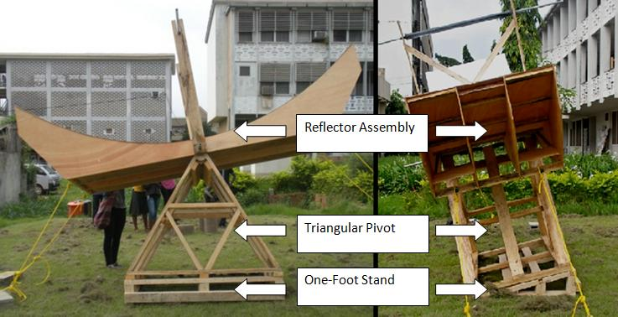
Figure ??? – Entire Assembly, Including Reflector Assembly, Triangular Pivot, and One-Foot Stand
Directions of Tilt
As shown in Figure ???1, below, the reflector needs to be able to tilt in two directions to accommodate daily and annual motion. Two different mechanisms provided for the ability to tilt the reflector to adjust for daily motion and annual motion.
Figure ???: Daily and Annual Motion
Adjusting for Annual Motion
Explanation of Science
The noon-time position of the sun varies in Kumasi, Ghana from 30 degrees south of the zenith on 20 December to 16 degrees north of the zenith on 23 June (see Calculation 1, Appendix G ???). Thus, it was important for our device to be able to tilt at least 30 degrees in one direction and 16 degrees in the opposite direction.

Tracking Daily Motion
Explanation of science
During the course of a single day, the sun appears to travel through the sky at a rate of approximately 15 degrees per hour. Actually, the rate varies during the course of a year. This is especially true for high lattitudes (even at RPI, for instance), where the sun traces out a shorter path across the sky during the winter and a longer path during the summer. This is one consideration for why – if automation were to be used in a future design to track daily motion – a closed-loop system should be used to sense and adjust for the position of the sun rather than simply programming in a rotation of 15 degrees per hour.
Alternatives considered for adjusting for annual motion
In order to adjust for annual motion, the reflector needs to tilt in the direction indicated in Figure ??? for annual motion.
Figure ???: Adjusting stand for annual motion
Four design alternatives were considered:
1. Option 1: A-Frame shelves
Option 1 would have consisted of building 2 “A-frame” stands with shelves at various heights upon which the pivot pipe for the reflector would rest. (See Figure ???, below.) By changing the shelf upon which the pivot pipe would rest, the annual motion angle of the reflector could be adjusted.
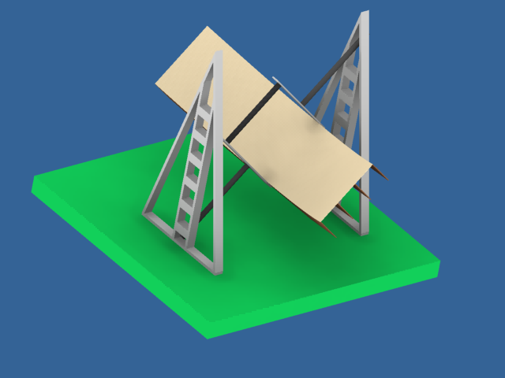

Figure ??? – Stands with shelves at various heights
One problem with this design is that it would have required extending the support pipe out significantly from each side of the reflector assembly so that the stands would be far enough away from the reflector to avoid coming in contact with the reactor stand (see Figure ???, below). Adding length to the support pipe also necessitates a higher maximum height for the stands to achieve the same angle.
Alternatively, the design could allow only one side to be adjustable, with the understanding that the device operator would need to rotate the entire device 180 degrees twice during each year. This would require the support pipe to have additional length only at one end.
With this design, a mechanism would have to be designed to secure the support pipe to the desired shelf while still allowing it to pivot. One other variation on the design could entail removing the shelves from the A-Frame supports and using an adjustable chain to hang the support pipe from instead.
One final problem is that if both sides were to be made adjustable, at any given time, one of the stands would be casting a shadow upon the reflector.
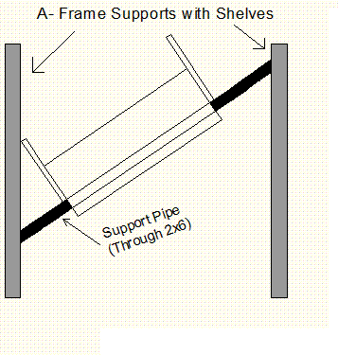
Figure ??? – Longer Support Pipe for Frame Supports with Shelves
2. Option 2: Adjustable-width stands in ladder base
Option 2 would similarly have featured either 1) one adjustable stand and one stationary stand or 2) two adjustable stands. However, in this design, the stands themselves would change heights, with the support pipe always attached to the top vertex of the stands. The height of the stands would vary by spreading or contracting the legs of each stand (Figure ???).
Figure ??? – Adjustable V-Stands with Support Pipe
In order to lock the angle of the legs of each stand, the feet of the stands could be placed in a ladder-like base. To adjust the height of the stands, the legs could be lifted and spread to the next widest pair of ladder rungs.
This option would have allowed the total height of the stands to be used towards the height of the support pipe. It also would have easily allowed for two adjustable stands so that rotating the device would be unnecessary.
One main concern was how to attach the support pipe to the top vertex of the stands. As each stand would be raised or lowered, the angle between the support pipe and the top of the stands would change. Thus, some sort of pivot or hinge would have needed to be applied between the top of the stands and the support pipe. Locking the support pipe into place with a metal strap would not have allowed the pipe to hinge upon the tops of the stands as they were adjusted.
The stability of this design was also somewhat uncertain; it seems that the v-shaped stands would have needed a brace in the direction into the page in the above figure. Still, this design is a possibility to consider for future prototypes.
3. Option 3: Extendable stands
Option 3 (figure ???) would have also featured two stands, one or both of which could be adjustable. This adjustment would be made by extending the stands vertically and inserting a pin at a set height, similar to the adjustable benches on many exercise machines. Pins would connect the tops of two extendable stands on each end. The pins would pass through a hole in the support pipe, allowing it to pivot as the height was adjusted for daily motion.
Figure ??? – Extendable stands
Using extendable stands would have eliminated the need for a ladder-base to lock the angle of the legs. It would also have used a lot of wood in order to create an outer casing and an inner sliding part of the extendable stands – though it could eliminate the need for the triangular pivot if the stands could be extended to heights between 4 and 6.5 or so feet (see Calculation 3, Appendix G ???). Additionally, the bases of the stands would have needed to either 1) slide along the ground or 2) hinge against a horizontal ground plate in order to adjust as the each side was raised or lowered during annual motion, since the horizontal displacement of the support pipe would change as its angle with the ground changes. Finally, since the inner sliding part of the stands would likely be made out of 2”x3” wood in order to fit within the casing, this design would have had questionable stability. If this design could be made more stable, it might be a consideration for future prototypes.
4. Option 4: Multiple stands with different heights
Option 4 was the most structurally simple design. In this design, stands of multiple different heights would be created. In order to achieve a 30 degree annual motion tilt, a 2-foot stand could be inserted below one end of the reflector, while the other end would be allowed to rest on the ground. An approximately 15.5 degree tilt could be achieved by inserting a 1-foot stand. (See dimensioned drawings in Final Design Analysis.) The device could be tilted in the opposite direction by switching the 1-foot or 2-foot stand to the other side. Finally, a 0-degree tilt could be maintained by using no stands at all. Thus, the device could achieve 5 predetermined angles to adjust for annual motion through the use of only 2 fixed height stands.
Option 4 was chosen for the final design. For more information, see Design Analysis.
V. Pivot Location
The group considered whether to place the pivot support pipe at the center of mass of the reflector or at the base of the reflector (through holes bored into the 2x6).
Placing the pivot near the center of mass of the reflector would have made adjusting and holding in place the daily tilt of the reflector require little force. This would also have prevented the design from using a support system (the triangular pivot) attached from below the reflector, and required the support pipe to be attached to stands only at the ends of the pipe. This would have necessitated a long support pipe in order to allow the stands to have adequate horizontal clearance from the base of the reflector. Increasing the length of the support pipe would increase the necessary height of the support stands as well. Figure ???, below shows the approximate location of the center of mass, one possible location for placing the pivot.
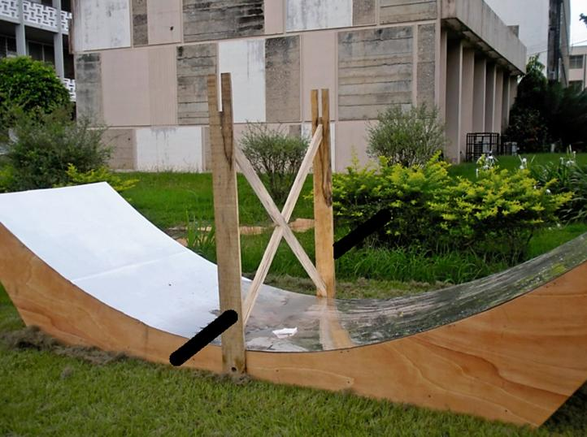
Figure ??? – Possibility of placing the pipe at the center of mass (not chosen)
Instead of locating the pivot at the center of mass, the group chose to locate the pivot in the base boards of the reflector. This allowed the use of a support system (the triangular pivot) which attached to the support pipe from below, rather than solely from the ends (as in the design with the A-Frame shelves – see System Concept Development…Adjusting for Annual Motion… Option 1). Since it was supported from below, the support pipe needed only extend for the depth of the reflector assembly. Thus, it needed only be 4 feet off of the ground on the low end instead of approximately 6 feet (see Calculations 2 and 3, Appendix G ???).

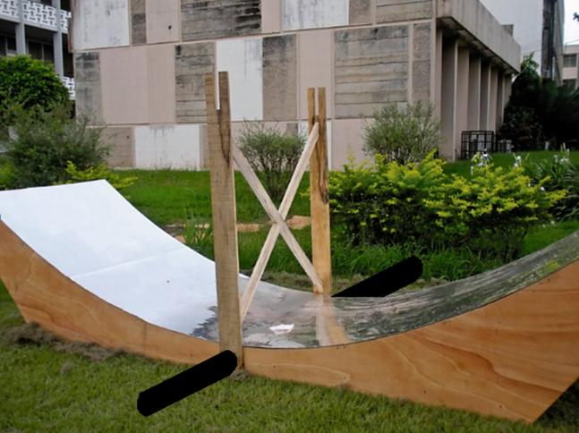
Figure ??? – Actual chosen location of support pipe (diameter exaggerated)
Alternatives considered for tracking daily motion
In order to track daily motion, the reflector needed to pivot in the direction shown in Figure ???2, below. The reflector pivoted about a support pipe placed at the top vertex of the triangular base.
Figure ???: Tilt of the Reflector During Daily Motion
Two alternatives were considered to set the tilt angle for daily motion.
1. Option 1: Adjustable props
The summer group at RPI used a wooden brace to prop the reflector to a certain daily motion angle. In a similar way, our design could have used adjustable supports to set the angle for daily motion throughout the day. This could have been achieved with extendable stands similar to the extendable stands suggested for annual motion (in “Adjusting for annual motion, Alternatives considered… Option 3,” above).
Again, the base of the extendable stands would need either to slide along the ground or to hinge against the ground. In retrospect, the entire assembly was easy enough to adjust that sliding the stands along the ground would not have been a problem.
2. Option 2: Adjustable chains or ropes
This option was originally designed such that chains would be attached to either end of the parabolic surface with the help of metal loops screwed into boards in the base of the reflector. The other ends of the chains would then be hooked to cinder blocks which also have loops. In order to tilt the reflective surface towards the direction of the sun at required time intervals, the chain on one end would be pulled further towards the cinder blocks and hooked to make it taut. With this procedure the chain could be either shortened or lengthened to make adjustments to obtain the required angle of tilt. Using ropes would be an alternative to using chains.
Option 2 was chosen for the final design. For more information, see Design Analysis.
6. Design Analysis
To Do: Introduce the methodology and analyses used in coming up with well-defined structure for the selected concept and major results. If the methodology is based on prior published work, cite the reference instead, with additional appropriate comments.
Examples of analysis techniques include:
- Technical/mathematical modeling
- Simulation
- Quick prototype and experimentation
- Present system and sub-system specifications used in your final design.
Annual Motion
Since Option 4 does not require the stands to be adjustable, it removes much of the complexity and potential for problems inherent in the other designs. It is quite easy three people working together to add or remove the stands below the triangular pivot. The stands themselves are rigid and strong.

The 1-foot stand (shown in Figure ???, below) provided for an annual motion tilt of 15.5 degrees. To complete the project, a 2-foot stand should be constructed for a 30 degree annual motion tilt. Admittedly, it is uncertain whether the device will be stable using the 2-foot stand.

Figure ???, below, shows the one-foot stand.
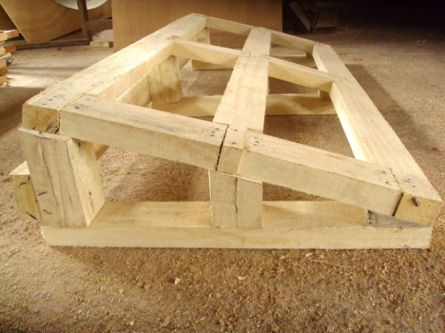
Figure ??? – One Foot Stand
Daily Motion

Ultimately, Option 2 was selected to track daily motion. Purchasing four, 12-foot chains, however, would have cost GHC 180 (120 US Dollars). Instead, ropes were purchased for a fraction of the cost.
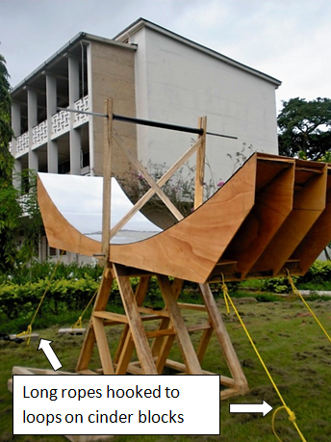
Figure ??? – Ropes to Secure Daily Motion Angle
One end of each of the four ropes was tied to a 2”x3” brace in the bottom of the reflector assembly. The other end should have been tied to a carabiner (see figure ???, below), which could be clipped onto a small rope looped around each cinder block. Carabiners, however, were difficult to find with little project time remaining, so key locks were purchased to accomplish the same purpose.
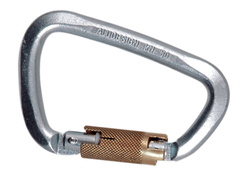
Figure ??? – A carabiner (photo from vtarmynavy.com)
Overall, the ropes hooked to cinder blocks worked very effectively to set the daily motion tilt of the reflector. The cinder blocks were plenty heavy enough to hold the reflector in place. In order to adjust the angle of the reflector, the cinder blocks were simply moved closer to or farther from the base of the reflector. This solution was simple, inexpensive, and easy to adjust. Figure ???, below show the reactor at its maximum (45 degree angle) tilt.
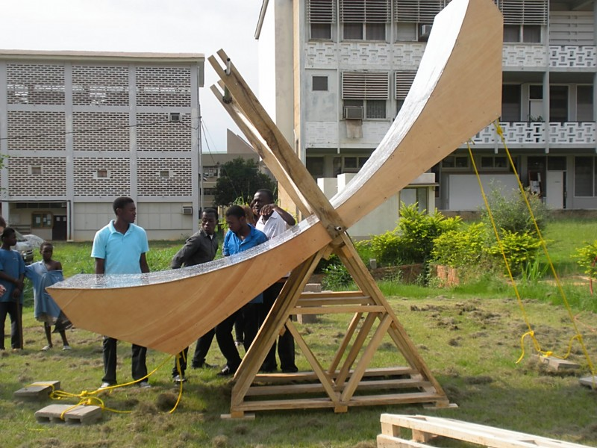
Figure ??? – Maximum (45 degree angle) Tilt

Achieving Ground Clearance: Triangular Pivot
The base of the reflector needed to be at least 4 feet above the ground in order to allow a tilt of 45 degrees during daily motion. (This would allow the device to function from 9:00 to 15:00. See Calculation 4, Appendix G. ???) Two options were considered to achieve this height. Either both of the stands could be built to a minimum height of 4 feet and extended beyond that height to adjust for annual motion, or the 4 foot height could be added by affixing a permanent support to the bottom of the reflector, and the stands would only need to be tall enough to provide the tilt for annual motion. We chose this option, since making both adjustable stands a minimum of 4 feet could have undermined stability. In order to provide the 4 feet of additional height, we constructed a triangular base affixed to the pivot of the reflector assembly.

7. Final Design and Engineering Specifications
To Do: Present the final design, including the detailed design, with appropriate diagrams/drawings with design values. Describe the critical design parameters with associated metrics that your design is addressing. Where applicable, address manufacturability and cost issues and include details in an Appendix. Similarly, organize and place large data tables and/or a set of detailed diagrams/drawings in Appendixes.

For a table of materials used and their costs, see Appendix ???. For dimensioned drawings, see Appendix ???.

8. System Evaluation
To Do: In this section, you show whether or not your design meets the end user requirements and engineering specifications. Concisely report your test procedures and results addressing following issues:
- Performance requirements
- Tolerance and Sensitivity
- Reliability and safety, including security
- Failure modes

Note that the reader should be able to reproduce the test results. Provide detailed procedures, equipment, and settings used in the tests in an Appendix.

Put here: temperatures we reached, did it work better or worse than we thought? how did it break? what are the safety precautions we need (gloves, cover for reflector, etc)

9. Significant Accomplishments and Open Issues

To Do: Discuss the evaluation results in terms of the final design. Describe significant accomplishments compared to your objectives. If you did not meet all objectives, or if you accomplished something that was not in your plan, explain why. Report planned tests that were not performed as open issues. If uncertainties remain, they should be pointed out also. If your results were not completely successful, state why the chosen approach (concept) is not viable or limited. (Unsuccessful results are useful in eliminating unproductive effort by allowing future design teams to learn from your mistakes.)
Make recommendation for design changes or modifying requirements/specifications as needed. This is also the place to suggest future enhancements based on lessons learned from this project.

Put here: list major things we accomplished, list things that we want to figure out (can be in question form)

10. Conclusions and Recommendations
To Do: Bring together, concisely, the conclusions to be drawn. Your conclusions must be supported by the material presented in the previous sections. Recommend next steps.

Split into two sections with Recommendations first. Recommendations really means future plans. We had lots of ideas that did not get implemented into this few weeks of work. This is the place where we can be very specific about what extra parts to make or ideas we had.
Future Plans
other stuff here

Areas for improvement for adjusting for annual motion
The current mechanism being used for annual motion has some possible problems:
- Several PVC spacers cut too large
- Somewhat bulky and expensive
- Likely unstable under 30 degree tilt
1. Several PVC spacers cut too large
This problem is solved by simply creating one new interior and two new exterior PVC spacers. The exterior PVC spacers are located between the outer faces of the outer plywood ribs and the pins which are inserted into the support pipe. The dimensions should be measured from the actual device.
2. Somewhat bulky and expensive
The 1-foot stand was constructed inexpensively using only 2”x4” wood. The triangular pivot, however, used 5, 12 foot 2”x6” boards in addition to some 2”x4”. Perhaps the triangular pivot could be constructed entirely from 2”x4” without losing much stability.
3. Likely unstable under 30 degree tilt
In order to solve this problem, a different scheme altogether might be necessary. One benefit of the triangular pivot and removable stand system is that the triangular pivot need only be 3.75 feet long. Unfortunately, this also means that under a 30 degree tilt, the reflector does not have a very deep base upon which to balance.
Areas for improvement for tracking daily motion
In order for the user to adjust the reflector to aim at the sun, the device needs some type of aiming mechanism. Currently, no such mechanism is in place. One possible suggestion is to extend a board out from the reflector with a hole drilled into it. A second board with a target drawn on it would be attached below this one. The shadow from the hole in the top board should be aligned with the target on the bottom board to properly aim the reflector. Other methods, of course, are possible.

Appendix G: Calculations
Calculation 1 – Annual variation in angle to sun (angle of declination from zenith):
Figure ???, below, shows the sun’s paths at three different times during the course of a year. The angle of declination from the zenith to the sun varies by 46 degrees (2 times the 23 degree tilt of the earth) over the course of a year, regardless of location on the earth. On 20 March and 23 September, the angle of declination from the zenith to the sun is equal to the latitude of the location. On 20 December*, the sun is found at an angle of declination 23 degrees farther to the north than in March and September (for locations in the Northern hemisphere). On 21 June, the angle is 23 degrees farther to the south.

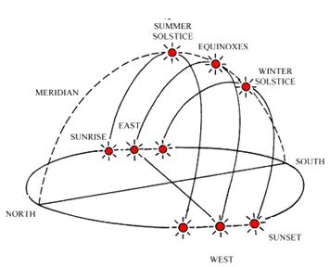

Figure ??? – Sun Paths during the equinox and solstices (approximate)
Image adapted from http://www.arch.hku.hk/~cmhui/teach/sunpath.gif
Thus, for locations in the northern hemisphere:
$$20 March and 23 September angle to Sun=Lattitude (with opposite direction)$$
$$=7 degrees towards the south for Kumasi$$

$$22 December angle to Sun=Lattitude (opposite direction)+23 degrees towards the south$$
$$=7 degrees south+23 degrees towards the south=30 degrees towards the south for Kumasi$$

$$21 June angle to Sun=Lattitude (opposite direction)+23 degrees towards the north$$
$$=7 degrees south+23 degrees towards the north=16 degrees towards the north for Kumasi$$

* The calendar dates may vary by 1 or 2 days each year. So instead of 20 December, the winter solstice may occur on 22 December.
Calculation 2 – Ground Clearance for Filly-Tilted Reflector with Support Pipe in 2x6 Base Boards:
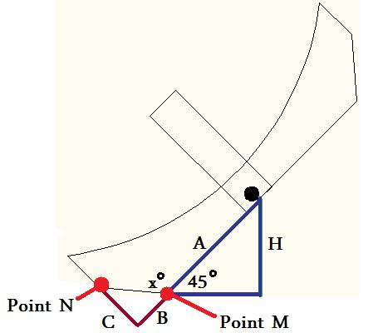
Figure ??? - Ground Clearance for Fully-Tilted Reflector

Table ??? Dimensions used in reflector design:
A | ? in
B | ? in
C | ? in

$$H=Asin45°$$
$$=?in$$
$$x°=180°-\tan^{-1}(\frac{C}{B})$$
$$=?°$$
Since x is less than 135⁰, Point M would contact the ground before Point N.
For the reflector assembly to clear the ground, then, the support pipe needs to be slightly more than H inches off the ground. That is, the support pipe needs to be at a height of about ???. The tilt of the reflector due to annual motion has little effect on the ground clearance of the reflector, since the support pipe does not extend out significantly from the ribs of the reflector assembly.
Calculation 3 – Additional Clearance Needed for Support Pipe at Center of Mass with Stands Outside Reflector
If, however, the support pipe had been placed at the center of mass of the reflector, the support pipes would have needed to extend approximately another 2 feet from either side of the reflector. (See discussion under System Concept Development… Pivot Location.) Since the support pipe could be at an angle of up to 30 degrees to adjust for the annual motion of the sun, the stands would need to be higher. See Figure ???, below.
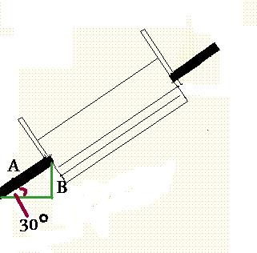
Figure ??? – Extra Stand Height Necessary
$$*B=Asin30°$$
$$= ?in$$
This would require the stand on the higher end to be ??? (2 times B) taller (from Calculation 6, above). Unless the entire device was designed to rotate, the opposite stand would also need extra height for when the sun moves into the opposite hemisphere. These additional height requirements helped us to choose to use a support system which attached to the support pipe from below – and thus required placing the support pipe in the 2x6 base boards of the reflector assembly, rather than at the center of mass.
* Note that the additional height would be slightly less than two times B, since the support pipe is now several inches higher on the reactor stands.
Calculation 4 – Required Tilt for Daily Motion
For the device to function from 9:00 to 15:00, it must function 3 hours prior to and 3 hours after 12:00 noon, when the sun is directly overhead. During these 3 hours, the sun traverses an angle of about
$3×15°=45°$.
Thus, the reflector is designed to tilt in 45⁰ in each direction along the axis for daily motion adjustment.

